A PROJECT REPORT ON



###### “Food Recipe Website”

Submitted In fulfillment for the award of the degree of

###### DIPLOMA IN COMPUTER ENGINEERING

To

#### BHAGAWAN MAHAVIR POLYTECHNIC

Submitted by

Rishi Patel : 2127010601123

Krunal Patel : 2127010601115

Kirtan Patel : 2127010601112

Parshwa Patel : 2127010601120

Under the Guidance of

Megha Jogiya

#### BHAGWAN MAHAVIR UNIVERSITY

**Academic year**

**(2023-2024)**

## CERTIFICATE



This is to certify that the domain work entitled **“Food Recipe Website”** has been carried out by **Rishi Patel (2127010601123), Krunal Patel (2127010601115), Kirtan Patel (2127010601112), Parshwa Patel (2127010601120)** under my guidance in partial fulfillment during their subject **major project-1** in **semester-V** of the Diploma in **Computer Engineering** at **Bhagwan Mahavir polytechnic, Surat** affiliated to **Bhagwan Mahavir University, Surat** during the academic of year 2023- 24.

***Guided By Head of the Department***

***Ms. Megha Jogiya*** ***Hiral Patel***

## DECLARATION

We, The undersigned hereby declare that project report entitle **Food Recipe Website** with special reference to Bhagwan Mahavir Polytechnic written and submitted by us in partial fulfilments of requirements for the award of diploma of Computer Engineering under the guidance of **Ms. Megha Jogiya**, is my original work and interpretations drawn therein are based on material collected by ourselves.

Signature:

Name : Rishi Patel

Enrollment : 2127010601123

Signature:

Name : Krunal Patel

Enrollment : 2127010601115

Signature:

Name : Kirtan Patel

Enrollment : 2127010601112

Signature:

Name : Parswa Patel

Enrollment : 2127010601120

## ACKNOWLEDGEMENT

It is our pleasure to present this project of **“Food Recipe Website”.**

At this moment, first of all we would like to thank the respected Head of the Department of our Computer Department **Ms. Hiral Patel** who gave us more detail on project.

We are also thankful to our guide **Ms. Megha Jogiya** and many more things are guided to our project.

And finally, our sincere thanks to my batch-mate, who had provided us with innumerable discussions on many technicalities and friendly tips. Without his cordial and friendly support, this activity might be much tougher.

We are also thankful to our Parents, Friends and Others for their opinions and support in the system.

**Yours Thankfully,**

**Rishi Patel**

**Krunal Patel**

**Kirtan Patel**

**Parshwa Patel**

## ABSTRACT

Introducing a culinary journey like no other, our Recipe Book is a delectable treasure trove of gastronomic delights. With an array of mouthwatering dishes meticulously curated from around the world, this collection caters to both novice cooks and seasoned chefs. Dive into the pages and uncover a symphony of flavours, from hearty comfort foods to exotic culinary adventures.

Each recipe is a step-by-step culinary guide, offering an opportunity to master the art of cooking while savoring unforgettable tastes. Whether you're seeking quick weekday meals or planning a gourmet feast, our Recipe Book is your passport to a world of culinary excellence. Prepare to embark on a culinary odyssey that will tantalize your taste buds and leave you craving for more. We are creating this website using HTML, CSS, Javascript, Php.

### List Of Figure

|  |  |  |
| --- | --- | --- |
| **Sr No.** | **Figure Name** | **Figure No.** |
| **1** | Home Page | **i** |
| **2** | About Us Page | **ii** |
| **3** | Login / SignUp | **iii** |
| **4** | Contact Us | **iv** |

### List Of Abbriviations

|  |  |
| --- | --- |
| PHP | Hypertext Pre-processor |
| HTML | Hypertext Mark-up Language |
| CSS | Cascading Style Sheets |
| JS | Java Script |
| SQL | Structured Query Language |
| DFD | Data Flow Diagram |
| ER | Entity Relationship Diagram |

### Table Of Contents

CERTIFICATE

DECLARATION

ACKNOWLEDGEMENT

ABSTRACT

LIST OF FIGURES

LIST OF ABBRIVATIONS

TABLE OF CONTENTS

CHAPTER: 1 INTRODUCTION

* 1. Overview
  2. Objectives

CHAPTER: 2 PROBLEM DEFINITIONS

* 1. Problem identification
  2. Problem solution

CHAPTER: 3 PROBLEM ANALYSIS

* 1. Software Process Model
  2. Software Requirement

CHAPTER: 4 OUTLINES OF THE SOLUTION

* 1. DFD
  2. ER Diagram
  3. Use case Diagram

**CHAPTER: 5 SNAPSHOTS**

**CHAPTER:6 CONCLUSION**

**CHAPTER:7 FUTURE SCOPE**

INTRODUCTION

**1.1 Overview :**

The "Food Recipe Project" is a web-based platform designed to provide users with a diverse collection of recipes from around the world. It aims to inspire and guide users in the kitchen, offering a wide range of recipes suitable for various tastes and preferences. The platform encourages both seasoned chefs and cooking novices to explore new flavors and embark on a culinary journey.

**1.2 Objectives :**

* **Diverse Recipe Collection:** Curate and present a diverse collection of recipes to cater to different culinary preferences and dietary needs.
* **User Engagement:** Create an engaging user experience that encourages users to explore, discover, and contribute to the recipe community.
* **Ease of Use:** Design an intuitive and user-friendly interface to make the platform accessible to users of all cooking skill levels.
* **Inspiration:** Inspire users to try new recipes, experiment with ingredients, and enjoy the process of cooking.
* **Community Building:** Foster a sense of community among users, allowing them to share their own recipes, tips, and experiences.

PROBLEM DEFINITIONS

**2.1 Problem Identification :**

The challenges addressed by the "Food Recipe Project" include:

* Limited access to diverse recipes.
* Difficulty for users to find recipes tailored to their preferences.
* Lack of a centralized platform for sharing and discovering recipes.
* Limited guidance for individuals seeking cooking inspiration.

**2.2 Problem Solution :**

The "Food Recipe Project" aims to solve these challenges by providing a centralized platform where users can:

* Access a wide variety of recipes.
* Easily search for recipes based on ingredients, cuisine, and dietary preferences.
* Contribute their own recipes and engage with a community of cooking enthusiasts.
* Receive guidance and inspiration for their culinary adventures.

PROBLEM ANALYSIS

**3.1 Software Process Model :**

The project follows an iterative and incremental software development process, allowing for continuous improvements and feature additions based on user feedback.

**3.2 Software Requirement :**

The key software requirements include :

* Web development framework
* Database management system
* Integration with external APIs for recipe data

OUTLINES OF THE SOLUTION

**4.1 Data Flow Diagram (DFD) :**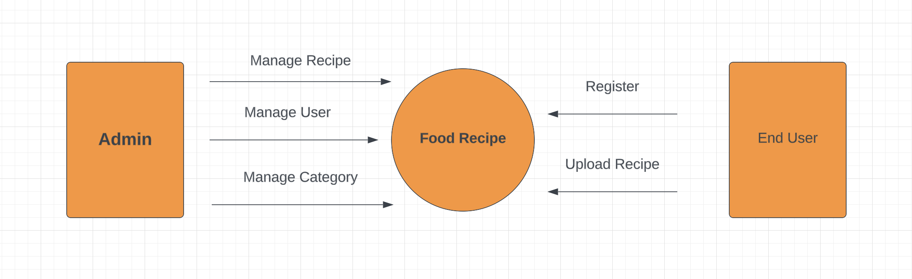

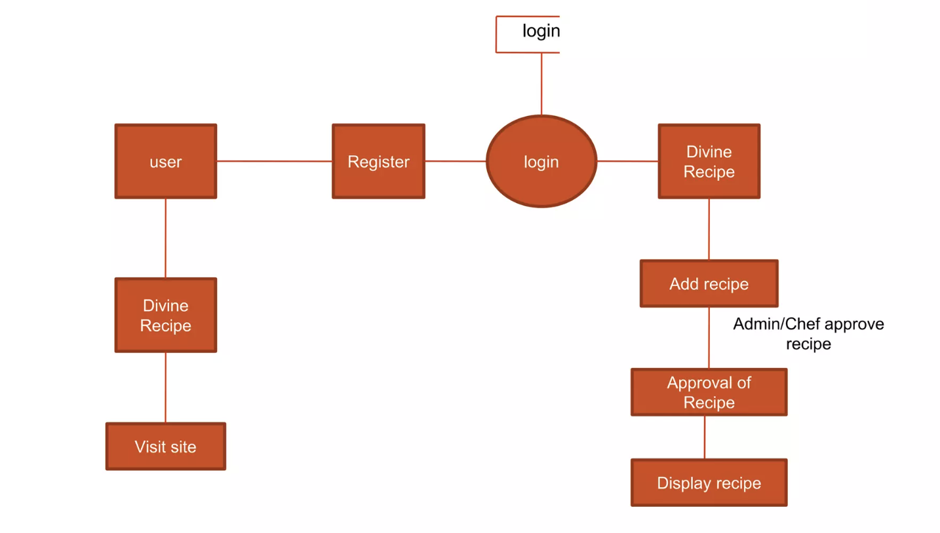

**4.2 Entity-Relationship (ER) Diagram :**

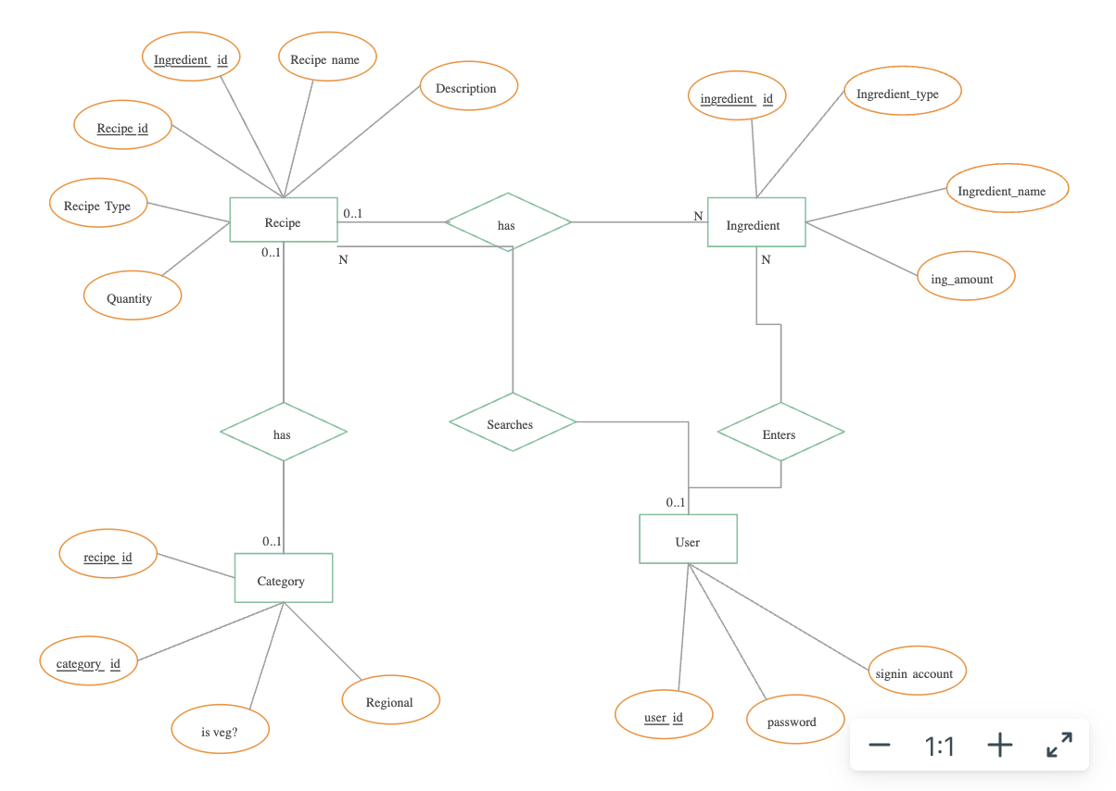

**4.3 Use Case Diagram :**

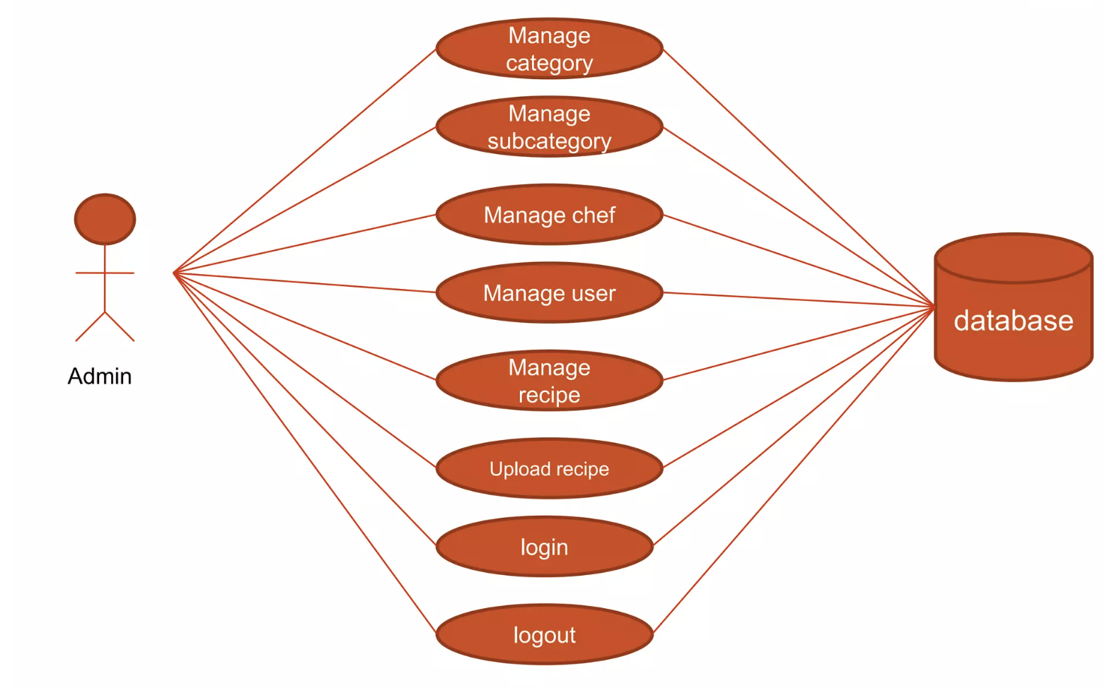

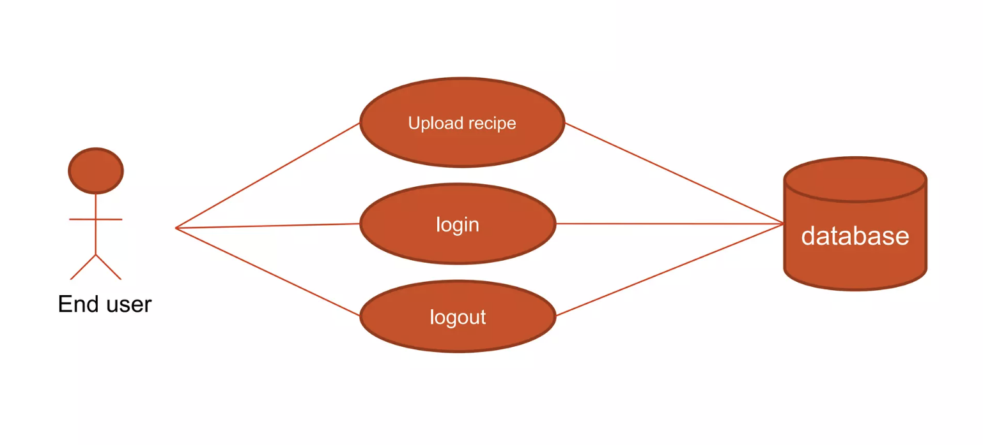

Snapshots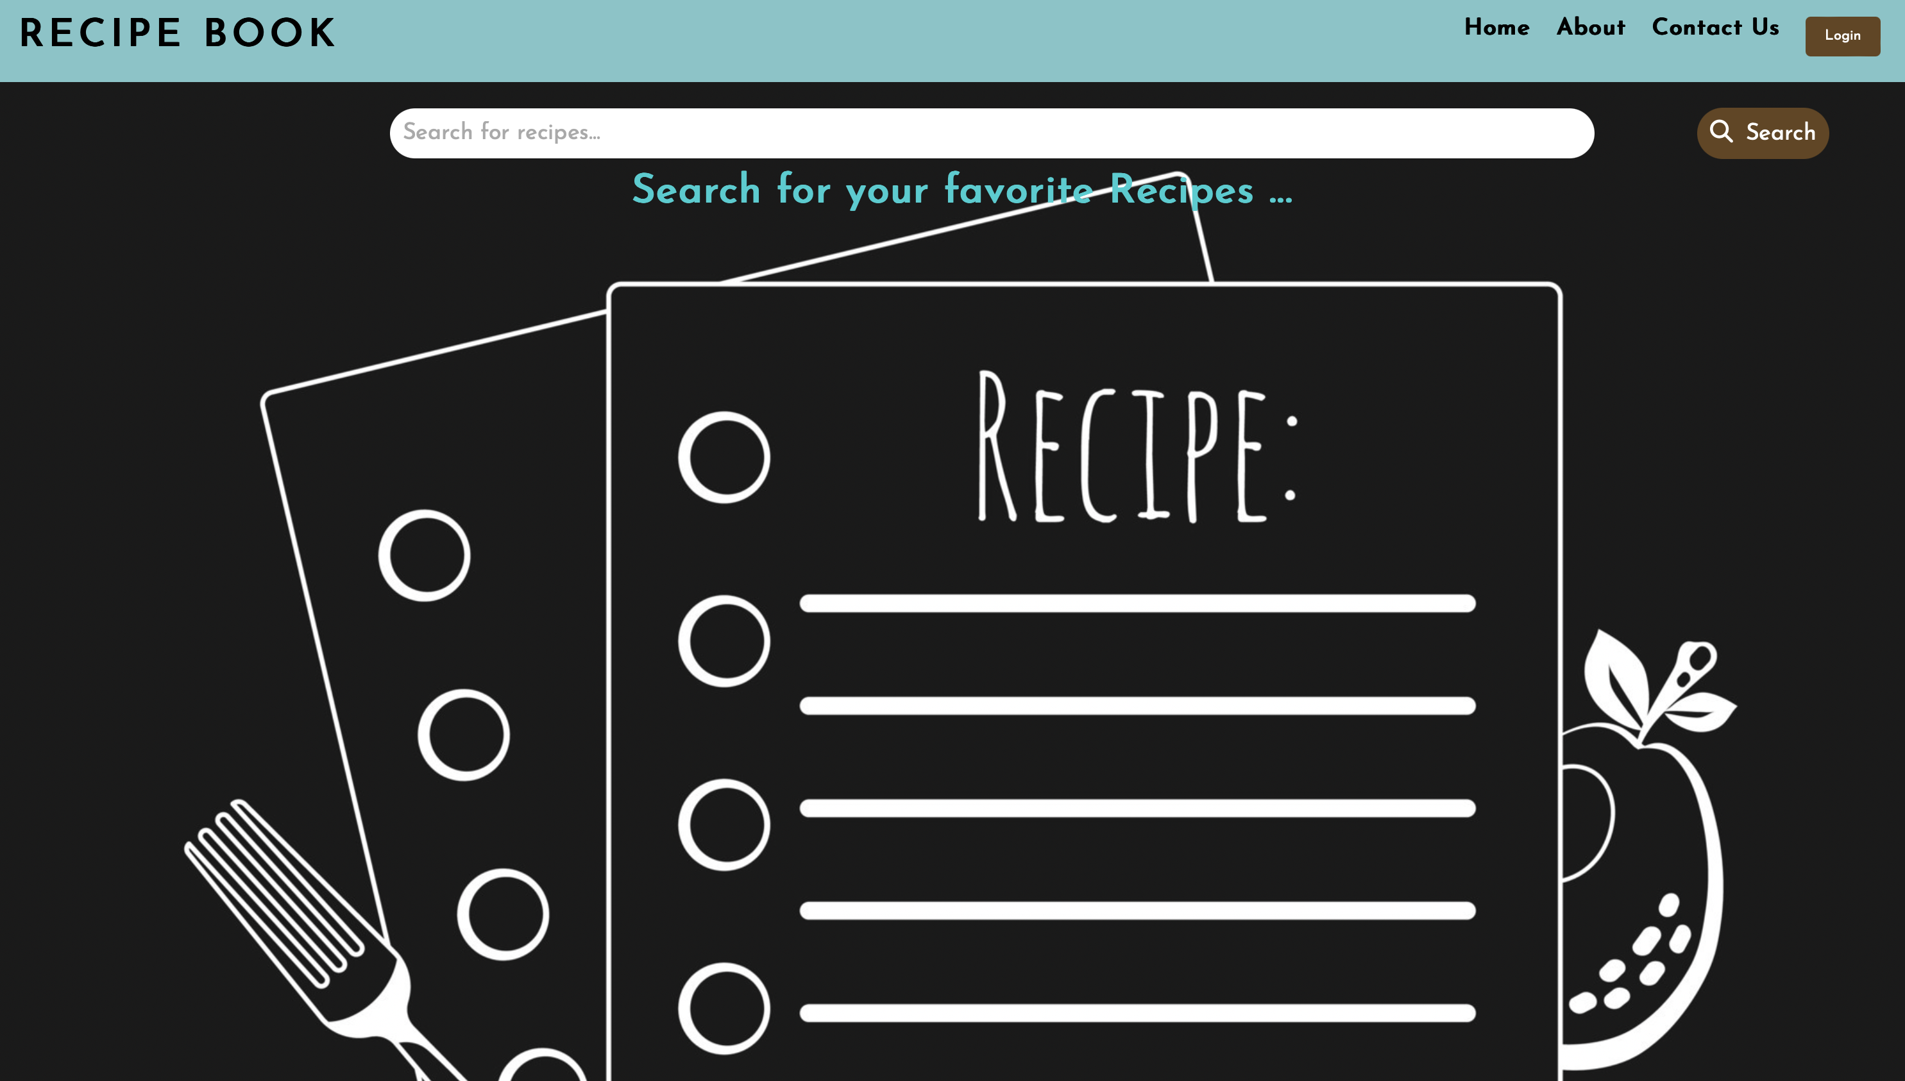

(i)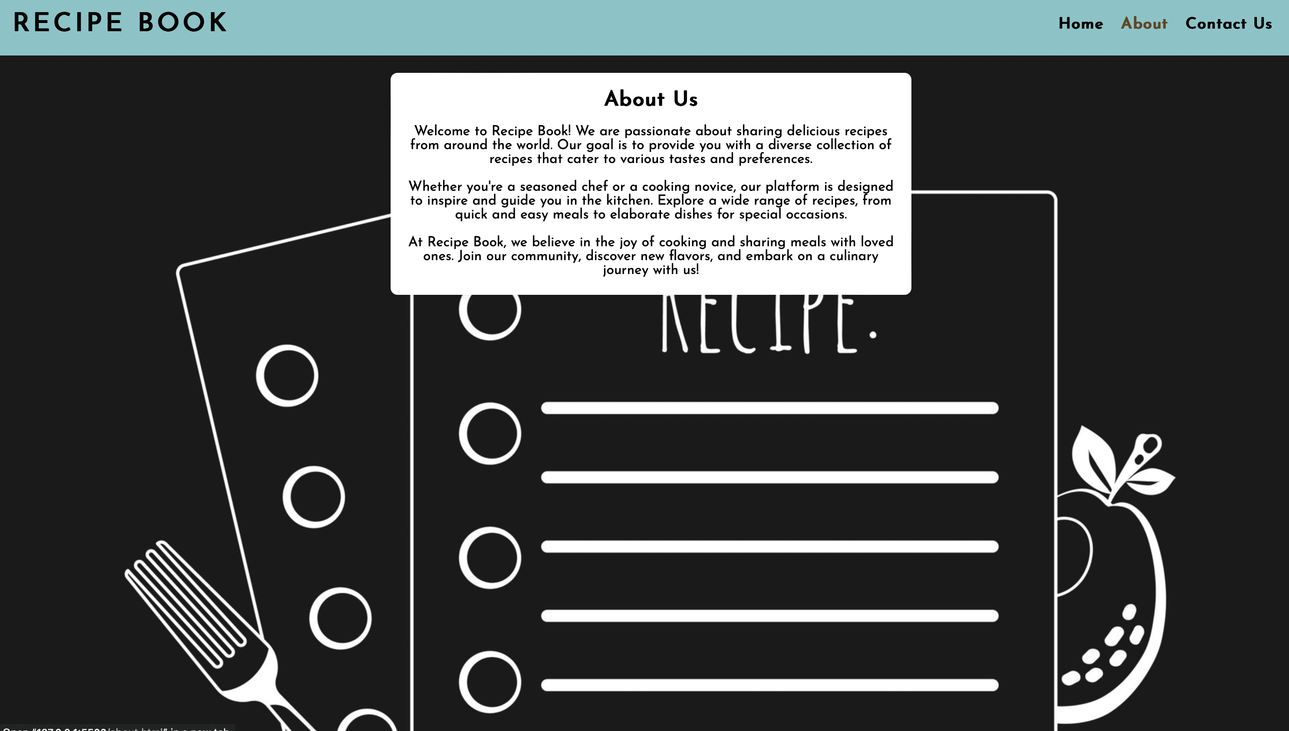

(ii)

(iii)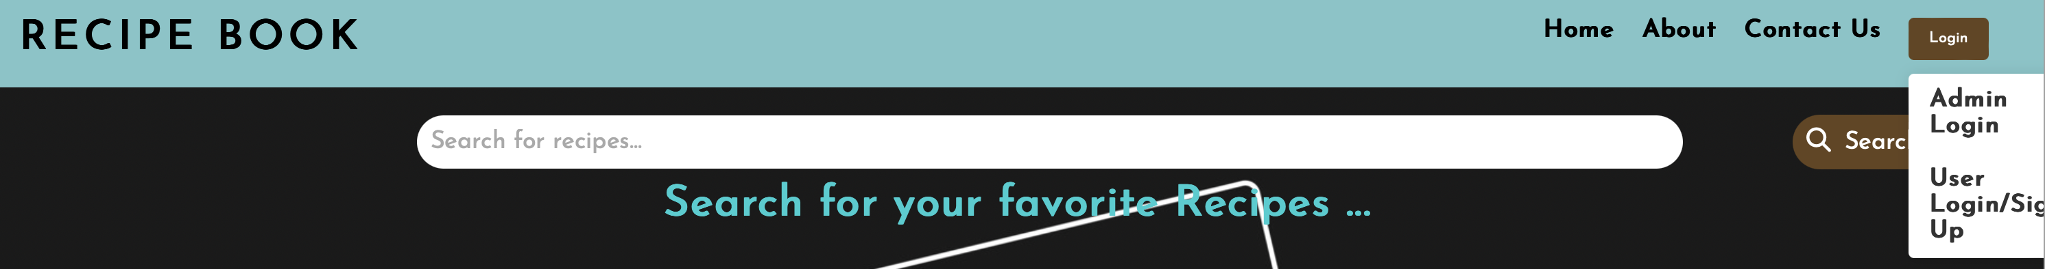

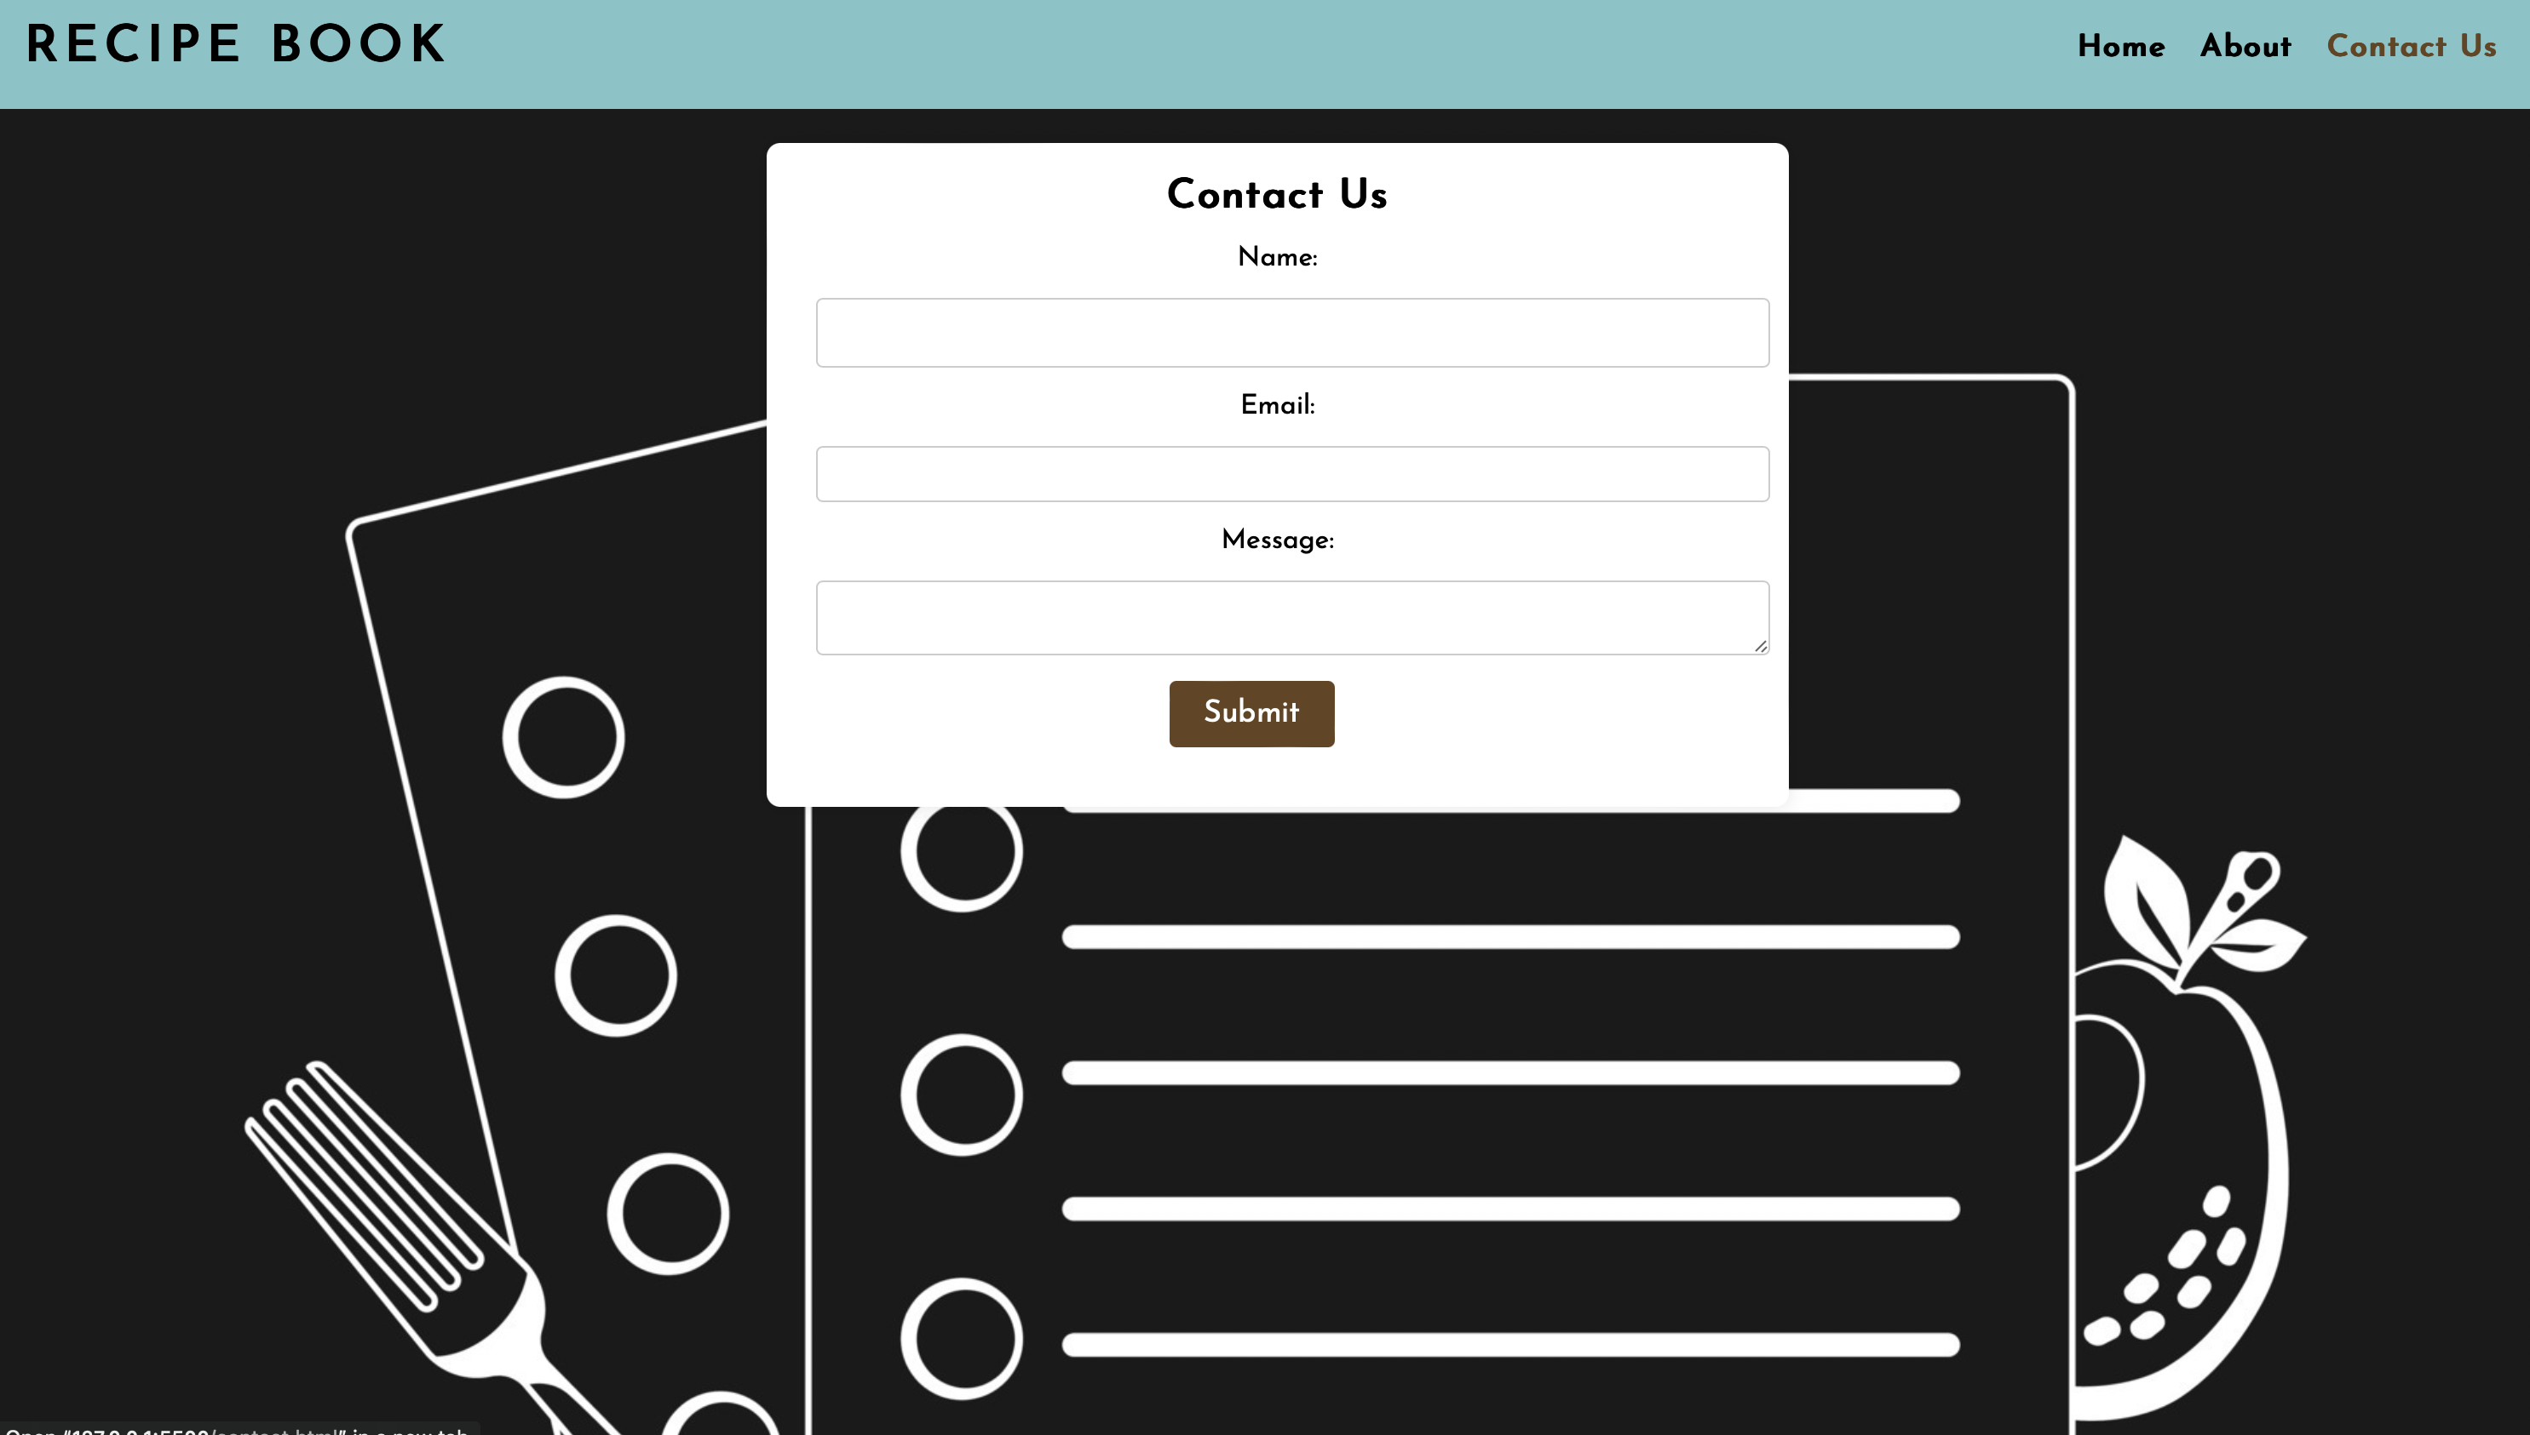

(iv)

Future Scope

The "Food Recipe Project" has significant potential for growth and enhancement. Future developments may include:

* **Advanced Recommendation System:** Implementing a personalized recommendation system based on user preferences, search history, and user-contributed data to offer more tailored recipe suggestions.
* **Interactive User Contributions:** Enhancing the user contribution features by allowing users to upload images of their dishes, share cooking tips, and engage in discussions about specific recipes.
* **Integration with Smart Devices:** Exploring integration with smart kitchen devices to provide users with step-by-step cooking instructions, ingredient measurements, and real-time guidance.
* **Mobile Application:** Developing a dedicated mobile application to make the platform more accessible to users on-the-go, facilitating easy access to recipes and community interactions.
* **Nutritional Information:** Providing nutritional information for each recipe, catering to users with specific dietary requirements and health-conscious individuals.
* **Cooking Challenges and Events:** Introducing cooking challenges and events within the community to encourage users to try new recipes, share their experiences, and compete in friendly cooking competitions.
* **Localization and Internationalization:** Adapting the platform to support multiple languages and regional cuisines, making it a global hub for culinary diversity.
* **Monetization Strategies:** Exploring monetization options, such as premium memberships, partnerships with food-related brands, and sponsored content, to sustain and enhance the platform.

Conclusion

The "Food Recipe Project" endeavors to revolutionize the culinary experience by providing a dynamic platform for users to explore, share, and enjoy a diverse range of recipes. Through this project, we aimed to address the challenges faced by individuals seeking culinary inspiration, limited access to diverse recipes, and a lack of community engagement in the cooking space.

The platform's user-friendly interface, coupled with a robust backend system, offers a seamless experience for users to discover new recipes, contribute their culinary creations, and connect with a like-minded community. The iterative and incremental software development process ensures continuous improvement and adaptation to meet the evolving needs of users.

In conclusion, the "Food Recipe Project" serves as a valuable resource for both seasoned chefs and cooking enthusiasts, fostering a sense of community and culinary exploration. The project aligns with the objectives of providing a diverse recipe collection, engaging users, ensuring ease of use, inspiring culinary creativity, and building a strong community.